Frosted Flakes Final Project
Mia Micaletti
ADVE 4100
Dave Wilcox
December 12th, 2023

Marketing Challenge:
- Frosted Flakes include a large amount of sugar in the cereal. With the new society of health-conscious consumers, Frosted Flakes has yet to fit into that new category. Frosted Flakes could use this insight to eliminate the amount of sugar they use, or they can have healthier variants such as reduced sugar or other more nutritious options.
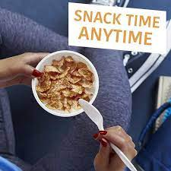
- This strategy would open the doors to a broader market, giving consumers more of an option with their breakfast/snack.
Media Goals/objectives:
- Use frosted flakes differently by eating them as a quick dry snack or topping for other foods.
- Moms with children on sports teams can get snack packs of frosted flakes to hand out as an early morning game treat to fuel the players.
Target audience:
- Stacy is a 32-year-old female who needs a quick breakfast for herself and her two kids. She is trying to give her kids healthy, cheap, and convenient breakfast options to start their day off right. As for herself, she works a full-time job, so she needs to eat something quick and delicious in the morning so she can have time to get her kids to school and drive to work.
- Middle- younger-aged women (demographic analysis)
- People who like to stay healthy and active (media habits)
- People who enjoy snacking (media habits)
- Race- Target all races
- Employment: Working full time to support family
Drivers, barriers, and aperture opportunities:

- Drivers: Emphasize Frosted Flakes nostalgic brand image and tie it with convenience for breakfast and snacking.
- Barriers: Address health concerns regarding sugar content by promoting reduced sugar variants or healthier options.
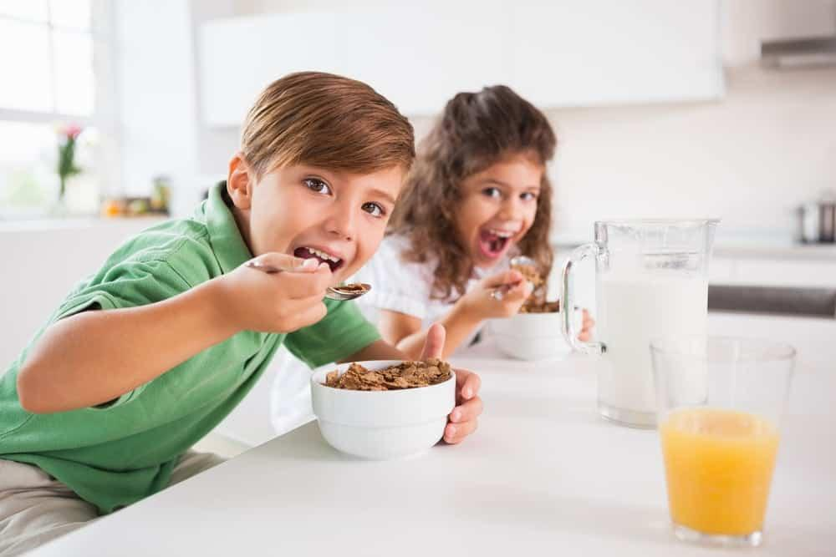
- Aperture opportunity: Engage both parents and kids during morning routines, reaching them on their way to work and while they're together at home to discuss breakfast choices

Insights:

- Media strategy insight: Frosted Flakes uses its brand image and nostalgia to engage consumers to purchase its products. They also engage their audience through collaborations, sponsorships, and promotions to keep the Frosted Flakes name relevant.
- Potential customer: Someone who appreciates a convenient breakfast option and enjoys a sweeter breakfast meal tied in with nostalgia for the brand. This person may have a busy lifestyle where they don't have the time to make a "gourmet breakfast" at home. Frosted flakes also may get the attention of those with kids who need something for both of them.
- The category sweet, classic cereals, where customers value taste and familiarity. It's like going to your favorite restaurant and getting the same thing every time because it never fails.
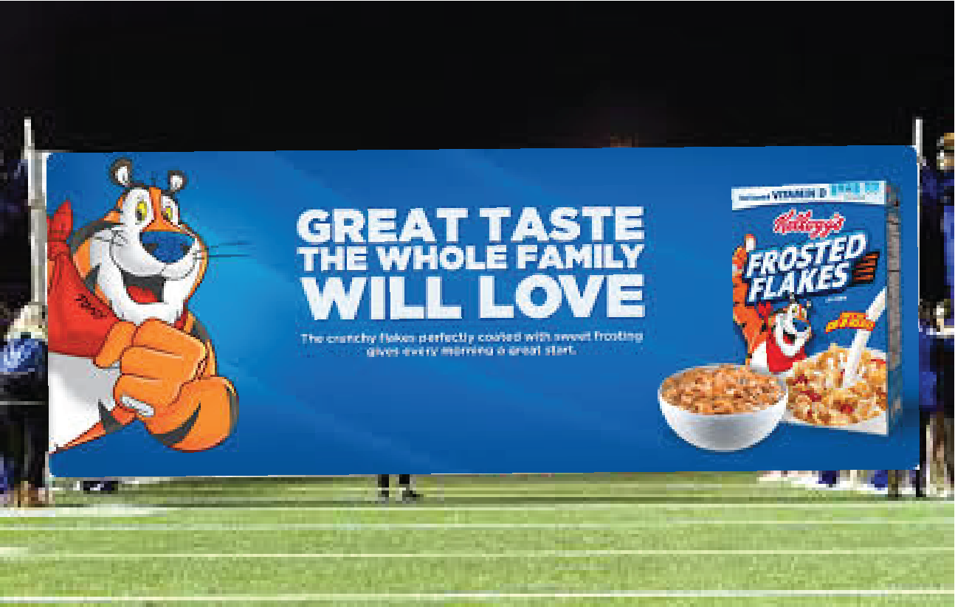
- The product: Emphasizing the unique taste and texture of the cereal that appeals to simplicity for breakfast that no other cereal can bring.

Strategies:

- Target Stacy specifically during her morning routine, emphasizing Frosted Flakes as a quick and delicious breakfast/snack while managing a busy schedule.
- Leverage the nostalgic and convenient aspects of frosted flakes to resonate with Stacy's needs for herself and her kids.
Tactics:

- Reach the children by displaying a colorful, kid-friendly poster of Frosted Flakes in the school cafeteria so they can run home and tell mom all about it.
- Reach Stacy with the utilization of Food blogs, for example, a segment on Frosted Flakes and the various ways to enjoy the cereal outside of eating it with milk.
- Employ media channels that reach Stacy during her morning rush, for example, radio ads during commute times or social media ads on Facebook or Instagram.

Promotional and merchandising ideas:

- Recipe cards with different ways to utilize frosted flakes
- Colab, with a foodie influencer, talks about versatile ways they eat frosted flakes, such as toppings, snacks, etc.
- Collab with popular sports teams like the NFL Dallas Cowboys to promote healthy and delicious eating for pre and post-game
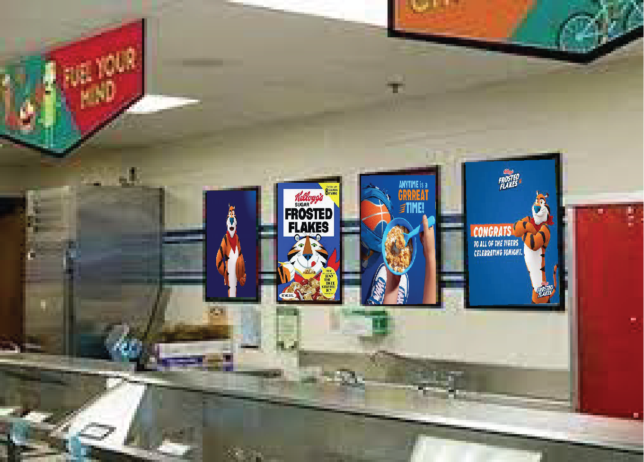
- A 20% promotional deal where you buy one Frosted Flakes snack cup and get the other free for a limited-time offer.
- Organizing a social media contest on Frosted Flakes Instagram using the hashtag #HowdoyoudoFF, asking followers to share the most creative way they use frosted flakes as a snack, where the most creative gets free Frosted Flakes for a year.
- Placing a Frosted Flakes vending machine in the middle of a big city like Chicago where it generates free Frosted Flake snack cups, cereal bars, and traditional cereal boxes- used as a PR stunt and, the more times people go up to the vending machine and press the button to get their treat, the more money that gets donated to a local charity.

A summary flow chart:

Strategy 1: Build Brand Awareness | Tactic 1: Colab with foodie influencer  Tactic 2: Colab with popular sports teams  Tactic 3: Organize a social media contest and post 3 times a day | Company  1. Jamie Oliver  2. Dallas Cowboys  3. Instagram | Week 1  -ASAP  - Near Superbowl  -Jan. 1st | Week 2  -Monday  -Near Superbowl  -Jan. 1st | Week 3  -Near Superbowl  -Jan. 1st
Strategy 2: Reach consumers | Tactic 1: Displaying FF in schools  Tactic 2: Utilizing a.m. radio ads  Tactic 3:  Food blogs | -CHMS  -WGN (720 kHz)  -Cookie And Kate | -ASAP  -everyday  -ASAP | -2 weeks  -Tuesdays a.m.  -ASAP | -1 week  -Tuesdays a.m.  -1 week

Citations
- British Heart Foundation. (2021, May 5). Breakfast cereals ranked best to worst. BHF. https://www.bhf.org.uk/informationsupport/heart-matters-magazine/nutrition/breakfast-cereals-ranked-best-to-worst#:~:text=Sugar%2Dfrosted%20cornflakes%20are%20high,or%20honey%2Dnut%20coated%20cereals.
- Tastewise. (n.d.). https://tastewise.io/foodtrends/frosted%20flakes
- Shanker, D., & Ren, H. (2021, February 11). Kellogg says it’s struggling to meet demand for Frosted Flakes. Bloomberg.com. https://www.bloomberg.com/news/articles/2021-02-11/kellogg-says-it-s-struggling-to-meet-demand-for-frosted-flakes#:~:text=Kellogg%20Co.%20has%20struggled%20to,pantry%20staples%20hard%20to%20find.
- https://medium.com/@Verkannt15/the-magic-behind-frosted-flakes-7dbf00a902cf

